**1)**  Yes, Since Circuit switched network end up harming its user instead of providing better service to them as path is decided between sender a receiver. It is used for Single Conversation.

For Example, in telephone network, each call is assigned with fixed number of bandwidths, irrespective whether they talk or not. This result in waste of bandwidth/ resources as user is assigned with some resource but he/she is not using it. If Circuit switched is used in Internet then for various activities requires low bandwidth or high circuit switched allocated high highest requirement, which is waste of resource.

**2)** In DSL, Telephone lines are used to provide internet service, Since, existing lines are thin it provides low bandwidth and the distance from local office to residential homes is usually large. Due to long distance, the signals get weak in transmission which affects quality of service i.e., get decreased. In order to provide better transmission while adjusting the cost, try to reduce distance between local office and homes, which result in reduction of the length of wire and increases the speed.

**3)** In Persistent-HTTP, Connection remain opens i.e., Connection is not created at every request. If there is not transmission of data after some time i.e., system remains idle which result in wastage of resource which is one of disadvantage of Persistent-HTTP. In this case non-persistent http is better to use.

While In non-persistent HTTP, for every new request connection is made which result in performance overhead

4) Various types of attacks towards DNS:

DDoS: make the huge number of connections so that any real device cannot connect.

DNS poisoning: Sending fake data to DNS servers, which saves the fake data in cache

and this data will be forwarded to the client.

Man-in-middle: keep an eye on the queries and spoof the client.

Bombard TLD Servers: Send large number of DNS queries which cannot be filtered.

5) Total of 14 routers involved in the process and number 15 is the amazon.in Web server

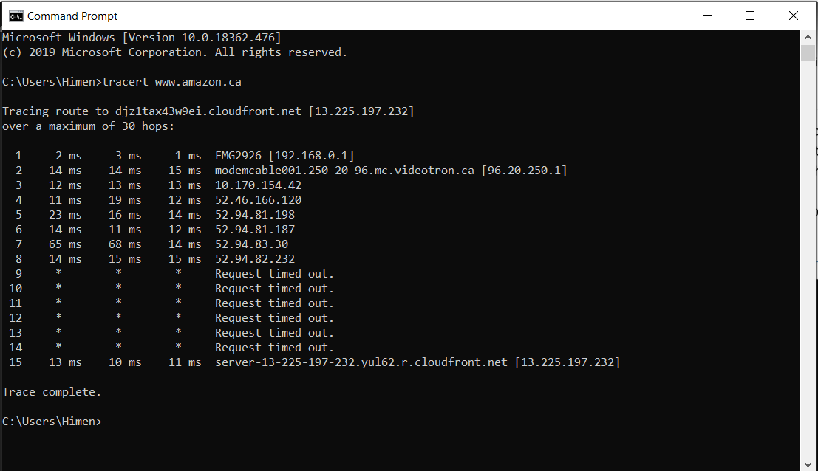

**6)**

a.

Propagation delay = Distance/Propagation Speed

= 12000*1000/2.5*108

= 0.048 sec

b.

Transmission delay = Packet Length/Bandwidth

= 2.46 sec

**7)**

a.

Propagation delay = Distance / Propagation speed

= 12000*1000/2.5*108

= 0.048 sec

b.

Transmission delay = Packet Length/Bandwidth

= 2*2/4 + 2*2/5 + 2*2/6

= 2.46 sec

c.

Propagation Delay = 0.048 sec

Number of Packets to be sent = 20/5 = 4 packets

Transmission Delay = 4*(5/4 + 5/5 +5/6) + 4*10-2

Total time = Transmission Delay + Propagation Delay = 12.3 sec

8)

Client Server

|  |  |  |  |  |
| --- | --- | --- | --- | --- |
| U | N | | | |
|  | 10 | 100 | 1000 |
| 300 Kbps | 7680 | 51200 | 512000 |
| 700 Kbps | 7680 | 51200 | 512000 |
| 2 Mbps | 7680 | 51200 | 512000 |

Peer to Peer

|  |  |  |  |  |
| --- | --- | --- | --- | --- |
| U | N | | | |
|  | 10 | 100 | 1000 |
| 300 Kbps | 7680 | 25906 | 47260 |
| 700 Kbps | 7680 | 15167 | 21524 |
| 2 Mbps | 7680 | 7680 | 7680 |

9) In tit-for-tat scheme of BitTorrent, Peers also contributes while downloading files. Therefore, decreasing the file distribution time and peer leaves the system once file gets download. If there are no more peers to contribute than the initial download speed will be very low which is disadvantage of this scheme.

References:

[1] Referred Textbook, Lecture Notes, Discussion Done during lecture